


Version: 5.1.2
Published date: August 2026
Copyright © 2026 by ESW. All rights reserved. Information contained herein is subject to change without notice.

Return Merchandise Authorization (RMA) INTEGRATION GUIDE

SFCC - ESW Cartridge
+
Contents
1 Return Merchandise Authorization 2
  - eShopWorld Order Return (ESW => SFCC) 3
1.1.1 ESW Webhooks Configuration 3
1.1.2 Workflow to Return Order in SFCC 4
2 Order Return Integration Configuration 4
2.1 Import Metadata 4
2.2 EswOAuthService 4

Return Merchandise Authorization
ESW SFCC Cartridge provides the capability to synchronize the returns initiated on ESW returns portal/center. When a order is marked for returns on ESW returns portal/centre, relevant returns payload information is stored in SFCC custom order attributes which can be used to further synchronize with other downstream systems.
  - eShopWorld Order Return (ESW => SFCC)
The ESW-SFCC Cartridge allows retailers to returns orders in SFCC if order is returned via ESW CSP first.
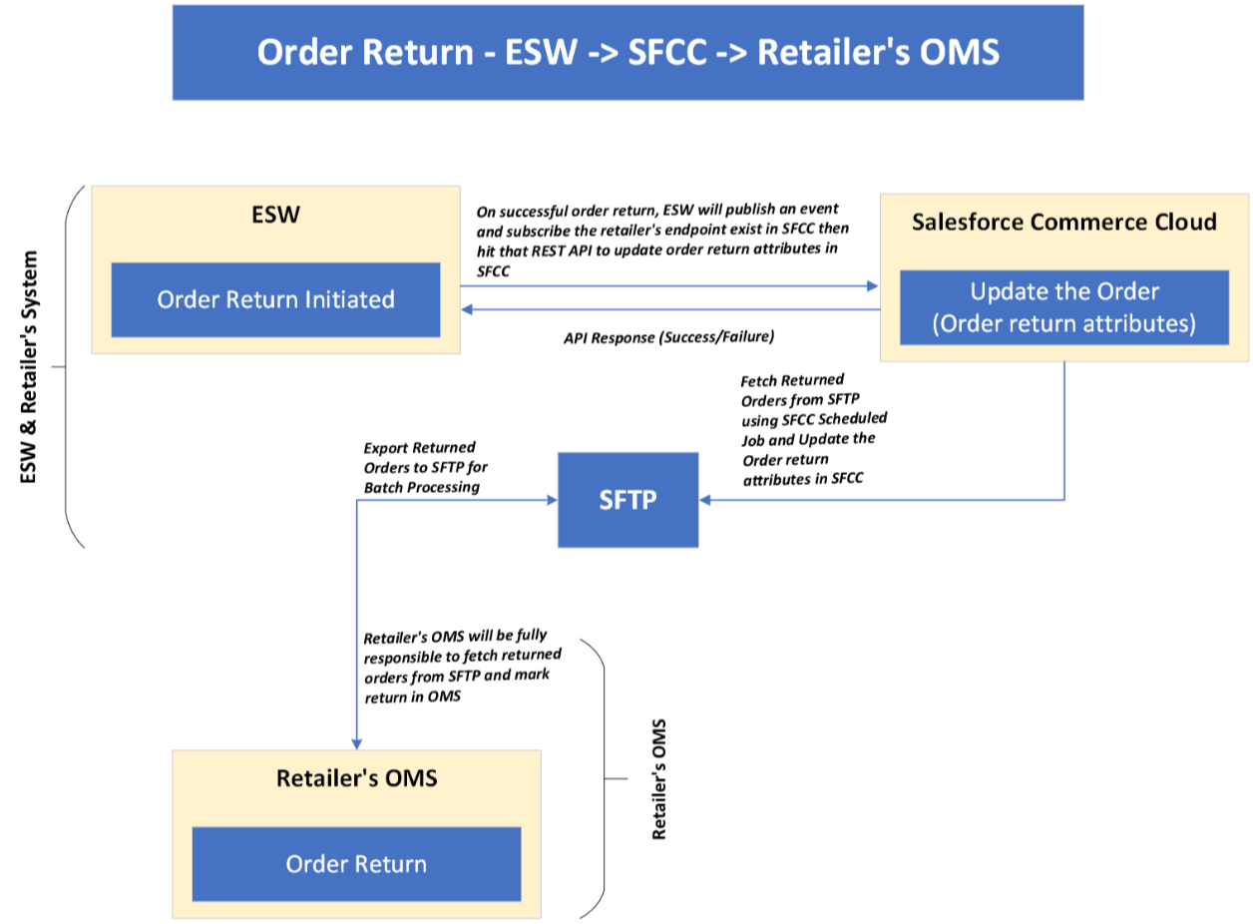
    - ESW Webhooks Configuration
Retailers need to subscribe SFCC API endpoint in ESW tenant configuration that will trigger on OrderReturnSucceedEvent. The ESW-SFCC cartridge provides the OOTB SFCC endpoint to subscribe with ESW order returns webhook event. ESW integration engineer can help retailers to subscribe this endpoint.
SFCC Endpoint Example:
https://example.com/on/demandware.store/Sites-RefArch-Site/default/EShopWorld-ProcessWebHooks
Retailers can update example.com with their storefront domain.
    - Workflow to Return Order in SFCC
The ESW-SFCC Cartridge perform the following to return order in SFCC If order is returned from ESW CSP first to sync order status in both systems.
- On successful order return in ESW CSP, webhook will trigger the retailers provided subscribed SFCC endpoint (EShopWorld-ProcessWebHooks) with returned order detail in request body.
- SFCC endpoint will park return order data in SFCC custom objects eswRmaJson and make eswIsReturned as true like below.
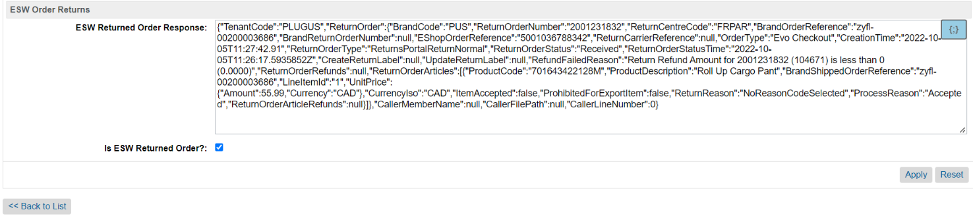

Order Return Integration Configuration
  - Import Metadata
Import order level custom attributes (systemobjects.xml) from link_eshopworld\sitesdata\meta.
The following ESW Order Returns custom attribute group will be present in Order Custom Attributes:
- ESW Return Order Response: This custom attribute will be filled with transaction reference if order successfully or even unsuccessfully returned in ESW and this will be in ESW Order API response.
- Is ESW Returned Order?: This mark order as return.
  - EswOAuthService
This service is used to get the authentication token from ESW. This token is used by other ESW services and APIs, such as Price Feed, Checkout, and Package.
Services can Import service from link_eshopworld\sitesdata\services.xml
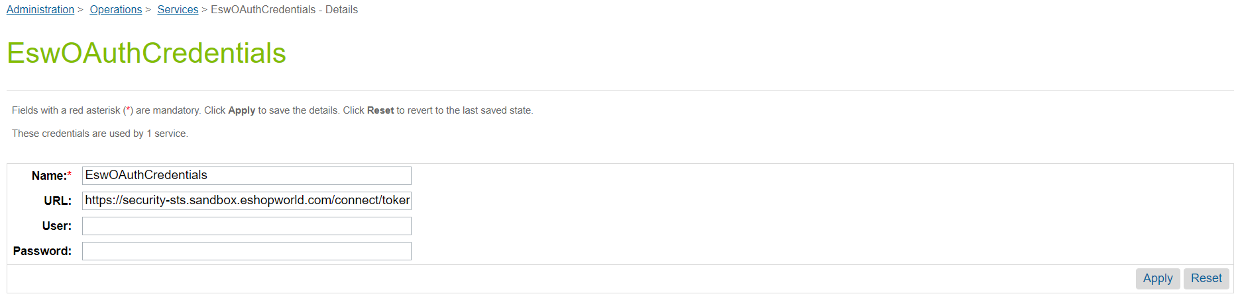
ESW OAuth Credentials

